Beacon Architecture Sustainable Architecture Project - Modules III-VI

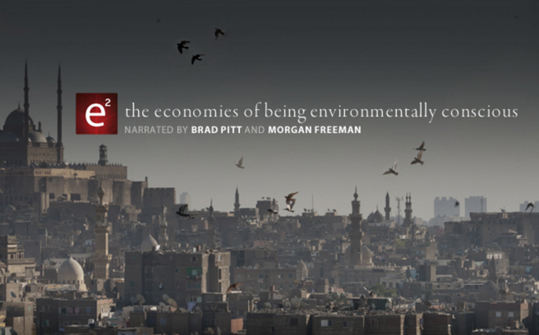
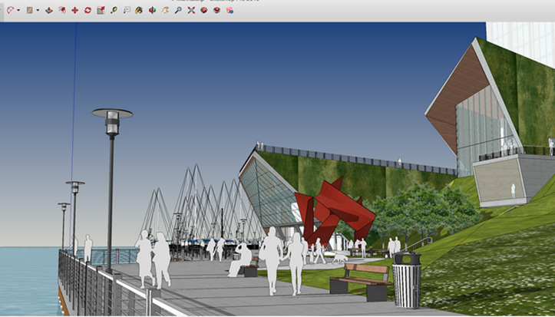
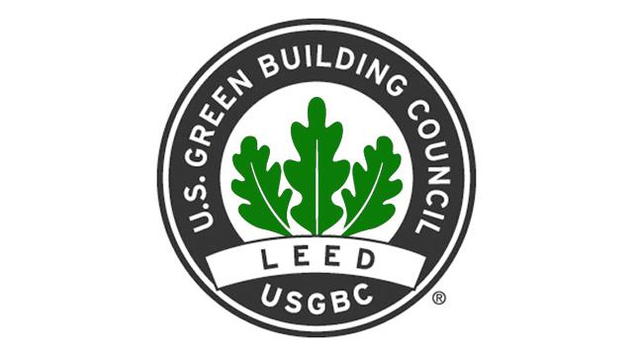

Module I – Research Module II – SketchUp Module III – LEED Analysis
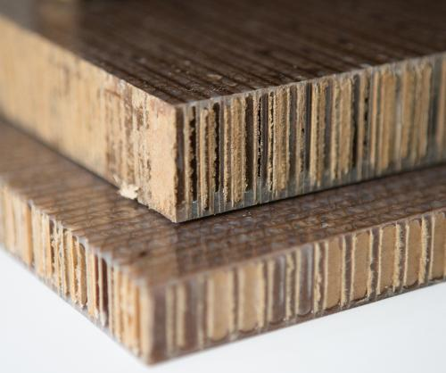
done! done!
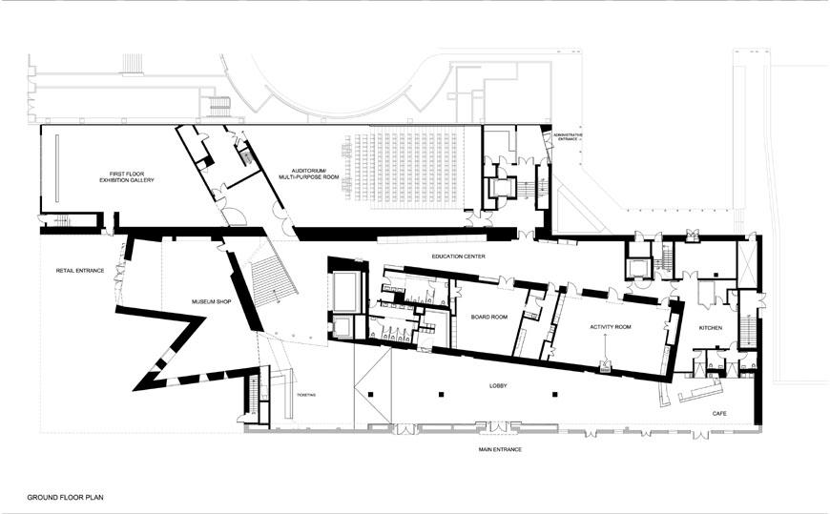

Module IV - Prezi Module V - Floor Plan Module VI - Upclycled
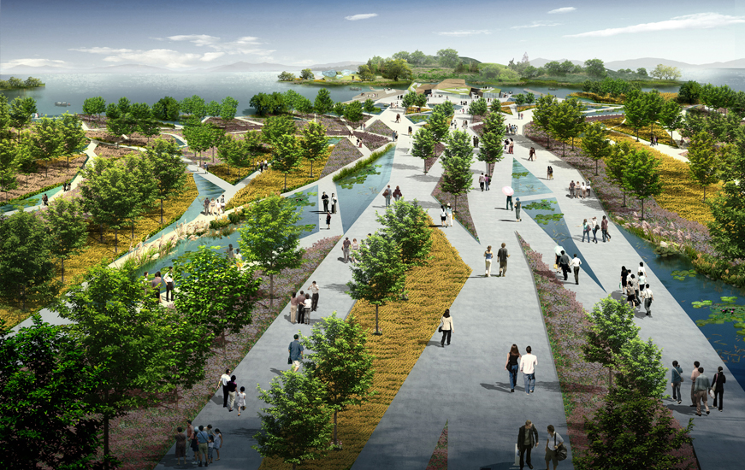
& Script & Elevation Material
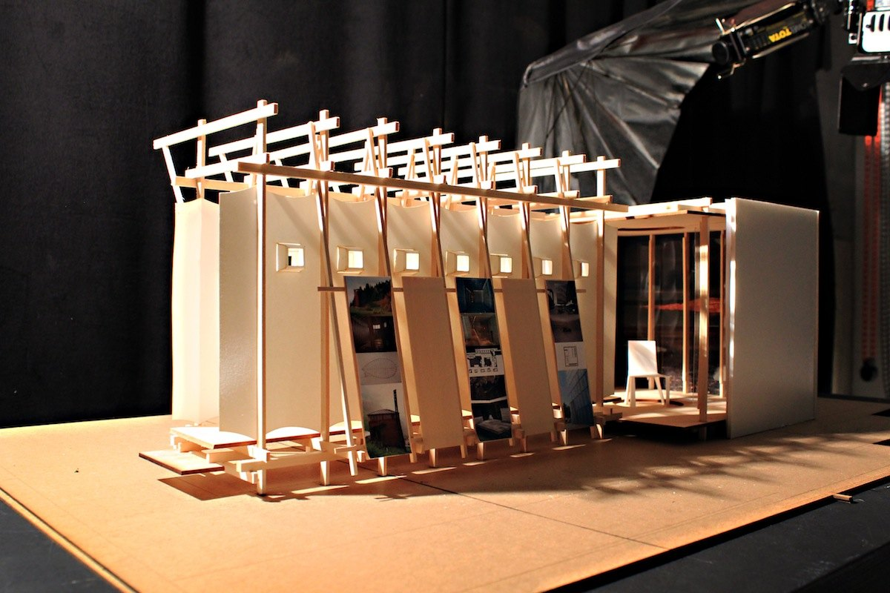
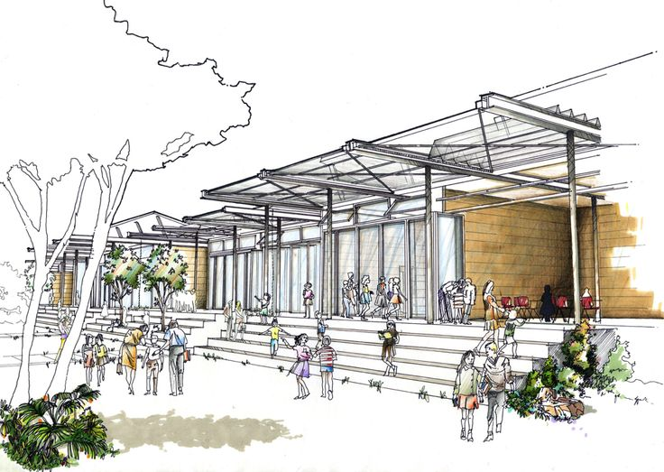
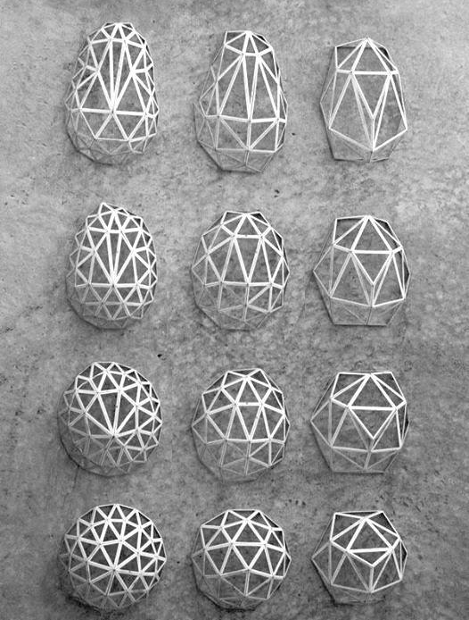
Extra Credit
Module VII – Physical Model - Landscape Design/Rendered Site Plan
_______________________________________________________________________

Module I – Research
- You should have researched sustainainability, your idea and everything having to do with it, cultural analysis, the natural resouces your area provides, sustainability having to do with the resources, local materials, cultural traditions, etc.
- You will not present ALL of your research, but it should be in a google doc that you can send me the link or print out to show me you’ve done a lot of thinking and work. Cite your sources and make sure they are available to you during your Oral Defense if an evaluator asks for them.

Module I – SkethUp Model
- This is your best SketchUp model yet! Details, details, details. If you have not spend over 10 hours on it, it is not detailed enough. Look to the example Ms. Daczka has provided.
- When you present your SketchUp model, you should show an interior (layers) and have an animation to help you present your design.

Module III – LEED Analysis
- Use the Excel spread sheet and analyze your building according to guidelines.
- This will force you to work out design decisions in your work that you may not have thought about yet. You may also go above and beyond the LEED requirements, to a negative consumption, or “productive architecure” which is not regulated yet.
- This is an informal analysis, using an official document. consult the LEED website with any quesitons regarding each checklist item.
- This analysis will guide you in your explanation and inclusion of all your sustainability features.

Module IV - Prezi & Script

- Start this early, work on it as you go along. This is like your “script” of your presenation.
- When you present your PBA, you will follow a sort of script. This will look like:
  - Introduction into Sustainability: much like the e² PBS videos, you will talk about facts and figures of sustainable architecture in a compelling and inspiring way. You may even show clips if you wish. You can also tell this like a story, first we investigated….
  - Your Idea: what you choose to design and why: link it to sustainability. Much or your Module I Research section will go into this section. Explain what you researched, why, how this led to your design decisions, how you were sensitive to the culture, etc.
  - Your design and the features: use sketchup Animation, physical model - if you have one - your floor plan, elevation to talk us through your entire idea.
  - Leed analysis: use the LEED checklist as a guide to walk your viewers through your sustainable features.
  - Your Upcycled product: include the product description, development, how it is cradle to cradle certified, and have the physical product there. Emphasize this is really a rough draft of what might be a future product. Now it is in it’s first stages of development. Have the actual product for them to see and touch.
  - Conclusion: much like the introduction, explain how your idea will be a model for future developers and builders and it is the first step in developing a more sustainable world.

Module V - Floor Plan

  - Should be ⅛”=1’ on vellum, pencil or INK (careful)
  - All floors should be represented.
  - Border, info box including name, scale project, etc.
  - You’ve done this before!

Module VI - Upclycled Material

  - Pick a material from our in-class garbage heap or any garbage heap and create a material from it that might be used in your project.
  - This can be a building material (ideally), a piece of furniture, a light fixture, insulation.
  - Name the product and give it a logo, create a whole advertising campaign around it.
  - Make sure your material is Cradle to Cradle Certified. Go to: http://www.c2ccertified.org/get-certified/product-certification
  - Upcycled Materials examples:
      - http://www.metacomb.com/
      - http://www.viralnova.com/upcycled-products/
      - http://www.treehugger.com/green-architecture/upcycle-house-goes-beyond-recycling.html

_______________________________________________________________________

extra credit
Module VII

- Physical Model - made out of wood or matt/museum board. those of you who have very basic SketchUp models should do this!
- Landscape Design/Rendered Site Plan - this can be done by hand with water colors, or digitally with a program of your choice. Ms. Daczka can show you tactics. Recommended for those who are designing cities or communities to show the entire design, which sketchup cannot.
- Upcycled Brochure and Marketing - go crazy! Make a brochure, or a commercial, or a webpage or an ad or anything that promotes your amazing product.

