Beacon Architecture name:_____________________________________________

Project #4: Divine Proportion Project Part IIII - Design of a Sacred Space

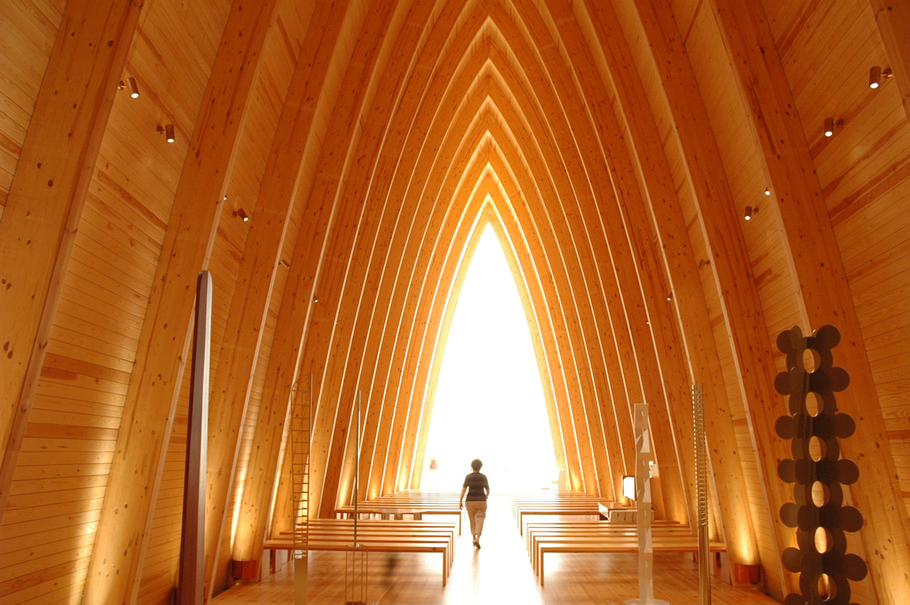
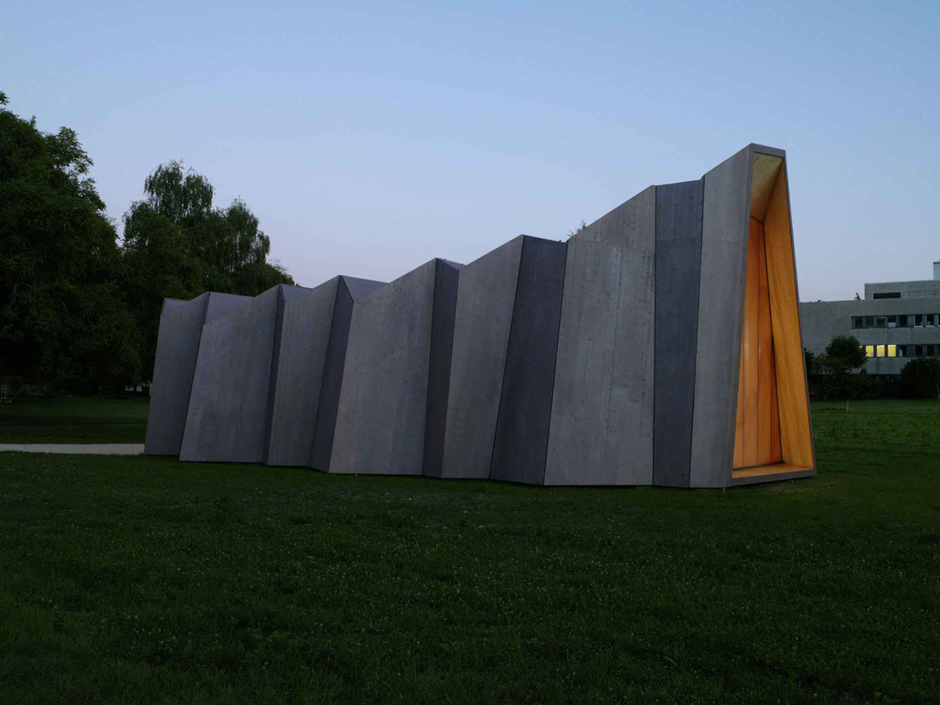
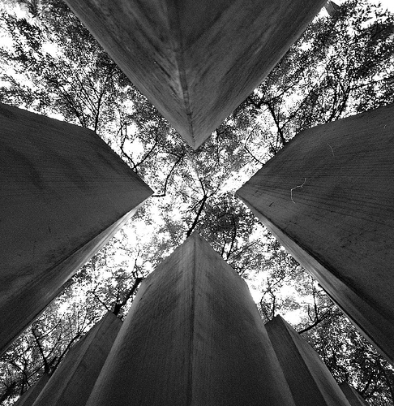

Project assigned: Monday, January | 11 | 2016
Presentation & Due Date: Tuesday, January | 26 | 2016

Assignment

You are responsible for designing a “Sacred Space” in Hells Kitchen. Because there are hardly any churches, temples, synagogues or any worshiping space, your space will be non-denominational. You will be designing for all people, regardless of their belief. These are the general requirements. You will design a…

- Gathering Space that allows for services or lectures, or some sort of group ritual.
- Memorial/Reflection Space that allows the visitor to remember people who have died and reflect on the fleeting quality of life.
- Natural Environment much like a park that allows visitors to commune with nature. This park should not be separate, but an integral part of your design.

Deadlines

I will assign deadlines in class as we progress through the design process. Please take note of any homework assignments, as they will be separate from your project grade and will be assigned to make sure you are keeping up with incremental goals.

Presentation
Bring all the following deliverables to your presentation that will be scheduled on Tuesday, January 26, 2016. You will have about 5-10 minutes to describe your space and walk me through your materials. I will ask clarifying questions and collect your deliverables.

READ THIS

Deliverables:

- Cover Page
- What is the Divine Proportion? In your own words, explain what Phi is, how it is connected to the Fibonacci sequence and spiral, how can we construct a Fibonacci rectangle? What is a more accurate way of writing Phi. What is the proof that shows us the construction is correct? Please rewrite this in a report format, don’t just hand in your test.
- Research Existing Structures Write-up. First, you need a description and at least 9 pictures of your 3 visited sacred structures WITH analysis of finding phi on each photo. Second, you need a description and at least 9 pictures of your 3 online researched sacred structures WITH analysis of finding phi on each photo (show me your attempts at dividing dimensions and finding phi. You should do this many times, not just once then calling it quits. An investigation means you exhaust all possibilities.. I assigned this for homework, and it was simply not done correctly for the most part. Please make sure you understand what is expected and do it carefully.)
- Sketches of Design Process (please leave in your sketchbook – DO NOT rip out) You should have many many pages, at least 20 sketches showing you put a lot of thought and effort before you started building a model.
- Description of your Sacred Space. Please describe your design in several paragraphs. Explain all the symbolism and what your intentions are though every design decision. If you handed this to someone, they should understand everything about your design.
- Sketch-up Model OR a Physical Model in 1/8”=1’ scale. The entire space should be included in all models. This means if the lot is 50’x150’, you should build the entire model out to show how you are using the entire lot space. Experimentation with materials is encouraged and CAREFUL and precise construction. If you use Sketchup, you must show the sketchup file in the presentation and print out at least 5 color photos to include within your report, with descriptions. If you use a physical model, this won’t be necessary.

Grading

This project is exactly the same weight as a Final Exam, 20% of your overall grade. I will give you the rubric as we get closer to the deadline, but your project grade will be broken down as follows:

18%: Attendance, tardiness and efficient use of class (3% per day)
22%: Written report with #1, 2, 4, 5 on the deliverables list above
10%: Sketches in your sketchbook
40%: Your model and overall design
10%: Your presentation on Tuesday, January 26th.

