Birdhouse Project Schedule & Requirements

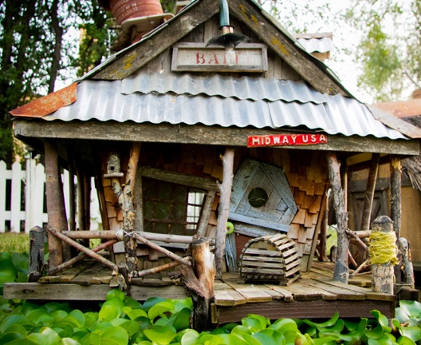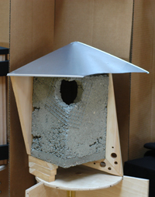

Project assigned: Friday, September | 18 | 2015
In-Class Concept + Program Review : Wednesday, September | 30 | 2015
Final Review: Monday, October | 5 | 2015

Requirements for final review:

- Scale model, scale 1”=1”
The following should be submitted together, staples or in a report cover, in the following order:
2) Copies of ALL your sketches. Do not rip them out of your sketchbook!
3) A typed-up report of your bird, providing information and a picture.
4) A picture of your birdhouse location, along with a map with it pinpointed.
5) A written explanation of why you chose the location.
6) A photograph of all your found objects.
7) A detailed, written walk-though of your design, answering the following questions:
a. What are all the features of your house?
b. How does the bird use your house?
c. What creative thinking went behind your design decisions?
d. How is an improvement over a typical nest?

