Beacon | Geometry name:

Band:

Geometry PBA Project PART I

Do Bees Build it Best?

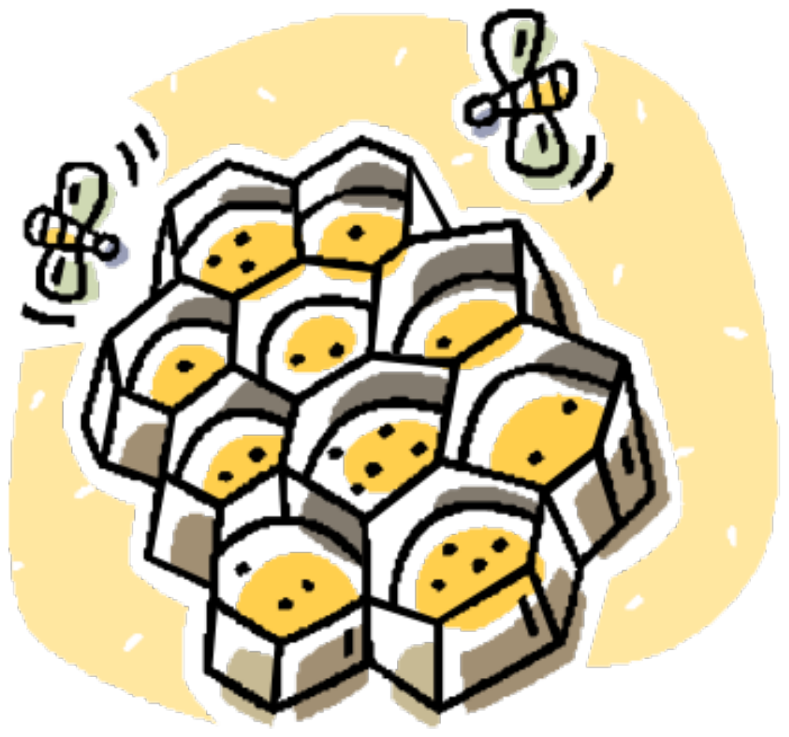

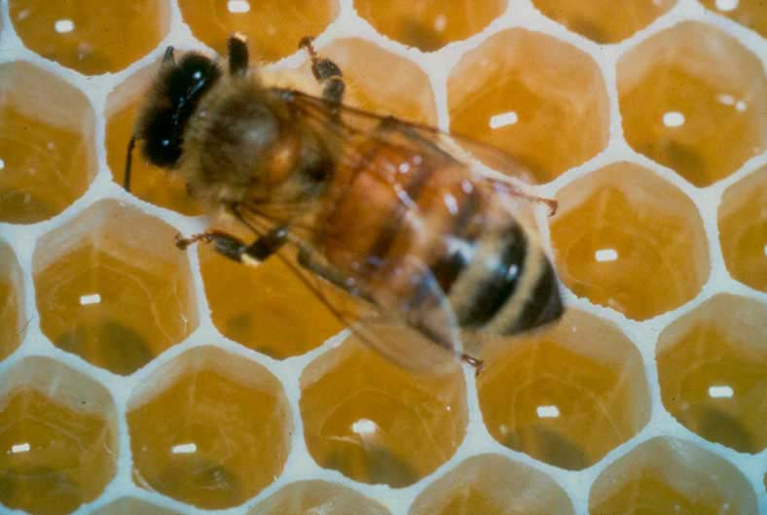

Let's Talk About Bees…

What do you know about bees ? | What do you wonder about bees?

Q: What shape is a single cell of a honeycomb?

Q: Do bees always build honeycombs like this?

Q: Why do you think they chose this shape? Make a few conjectures.

Part I - Volume

Essential Question

This question is the main question in the project. We will be constantly coming back to it. Emblaze this into your consciousness.

Why do bees build hexagonal honeycombs?

You will be able to answer this question by the end of the exhibition. First, let's investigate other shapes a bee could possibly build with. What if bees built in other shapes? Would they hold as much honey?

Let’s conduct an experiment based on this last question! We are going to investigate different regular shape honeycombs to see if the hexagon holds the most honey.

Q1: How can we compare different shape honeycombs volumes? Can we compare random sizes?

Let’s make the perimeter of each honeycomb a constant of 300 units, and the height (depth) of the honeycomb 2 units.

Q2: Again, why did we do this?

When we find the volumes of each shape, we will then record our data on the Volume Comparison Chart on last page of this packet. If the honeycomb with the largest volume is the hexagon, we will know why bees build with hexagons.

Let’s Start!
TRIANGLE
Honeycomb

Draw a regular (equilateral) triangle with a perimeter of 300 units. Find the area. This is your honeycomb base. Then find the volume of the cell and record the volume on your volume comparison chart. Show all sub-problems!

Area of Base: ______________

Volume = (Area of Base)(height of honeycomb) Volume:

SQUARE
Honeycomb

Draw a regular quadrilateral (square) with a perimeter of 300 units. Find the area. This is your honeycomb base. Then find the volume of the cell and record the volume on your volume comparison chart. Show all sub-problems!

Area of Base: ______________

Volume = (Area of Base)(height of honeycomb) Volume:

PENTAGON
Honeycomb

For the pentagonal honeycomb, we will need to break the shape down into shapes we know how to find the area of, for example, rectangles, triangles, and trapezoids. For Method #1, you will choose the way you break it down. Use all your trig and triangle math tools to find angles, sides and areas.

METHOD 1:

Show all your math CLEARLY below.
PENTAGON
Honeycomb

Let’s save time for method 2. Can you break the shape down into 5 equal triangles? Now find the total area of the pentagon. Is this easier?

METHOD 2:

Show all your math CLEARLY below.

Area of Base: ______________

Volume = (Area of Base)(height of honeycomb) Volume:
HEXAGON*
Honeycomb
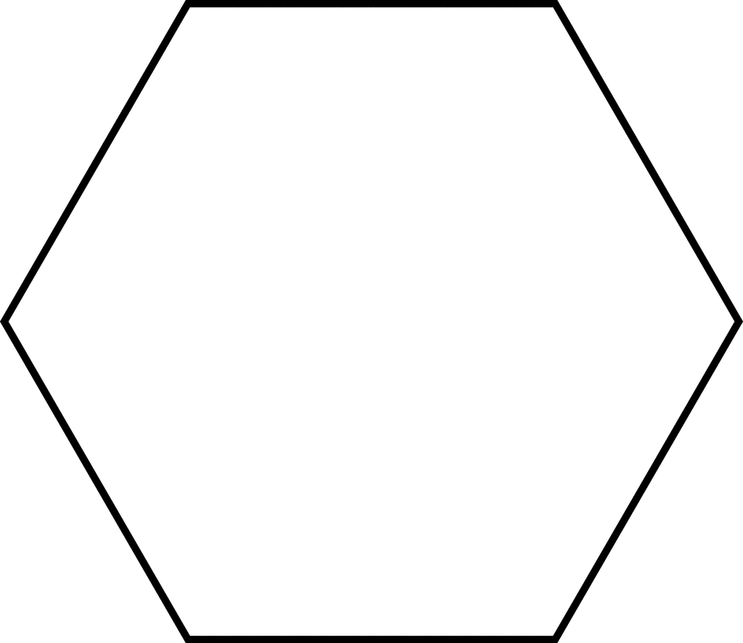

Area of Base: ______________

Volume = (Area of Base)(height of honeycomb) Volume:

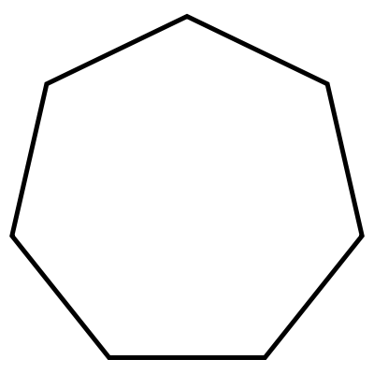
HEPTAGON
Honeycomb

Area of Base: ______________

Volume = (Area of Base)(height of honeycomb) Volume:
OCTAGON
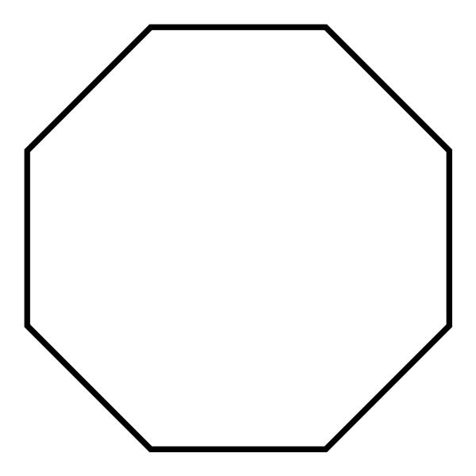
Honeycomb

Area of Base: ______________

Volume = (Area of Base)(height of honeycomb) Volume:

NONAGON
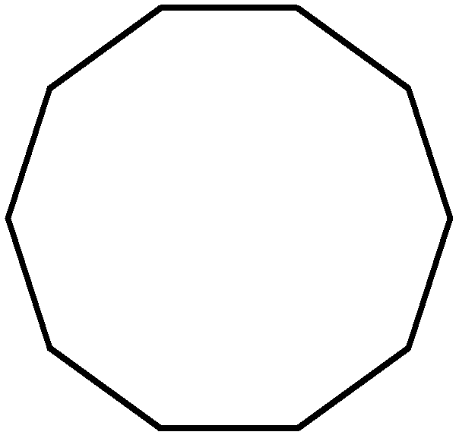
Honeycomb

Area of Base: ______________

Volume = (Area of Base)(height of honeycomb) Volume:

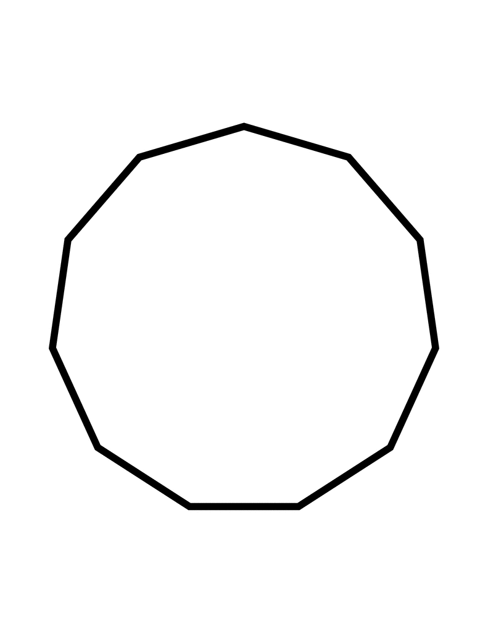
DECAGON
Honeycomb

Area of Base: ______________

Volume = (Area of Base)(height of honeycomb) Volume:

CIRCLE
Honeycomb

Area of Base: ______________

Volume = (Area of Base)(height of honeycomb) Volume:

HONEYCOMB VOLUME COMPARISON TABLE

# of sides - Regular shape | Volume (when height or depth is 3 units)
3 - Triangle

4 - Square

5 - Pentagon

6 - Hexagon

7 - Heptagon

8 - Octagon

9 - Nonagon

10 - Decagon

∞ - Circle

This table is incredibly important. Without it, you will not be able to answer the essential question: Why do bees build with hexagons?

Q3: Which honeycomb shape had the largest volume? Why is this so?

Part II - Tesselations

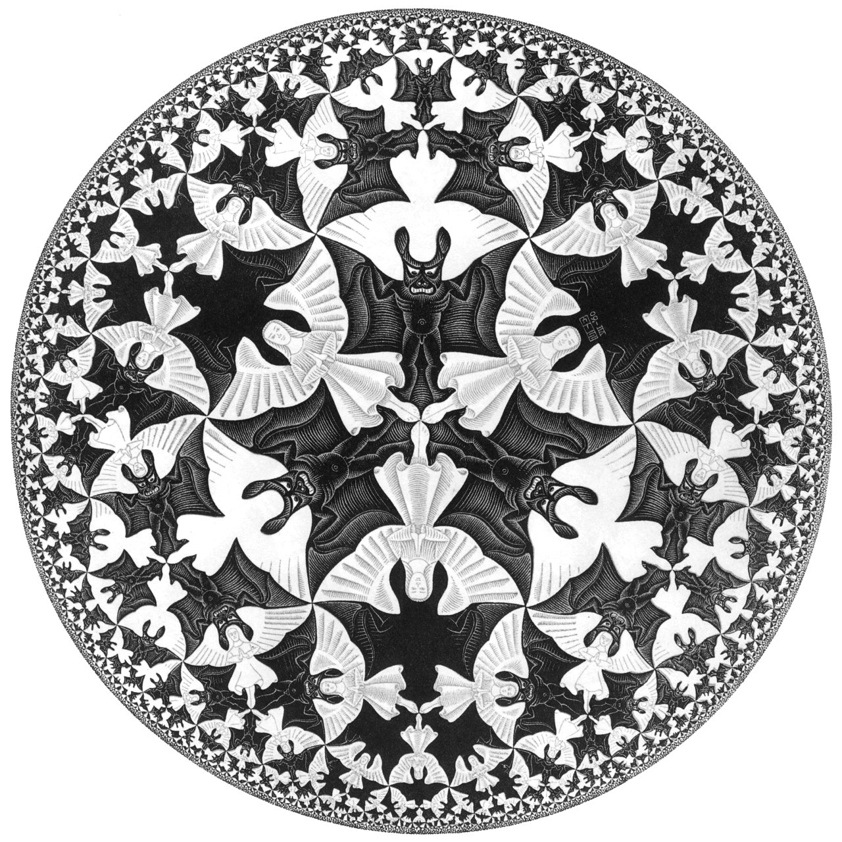
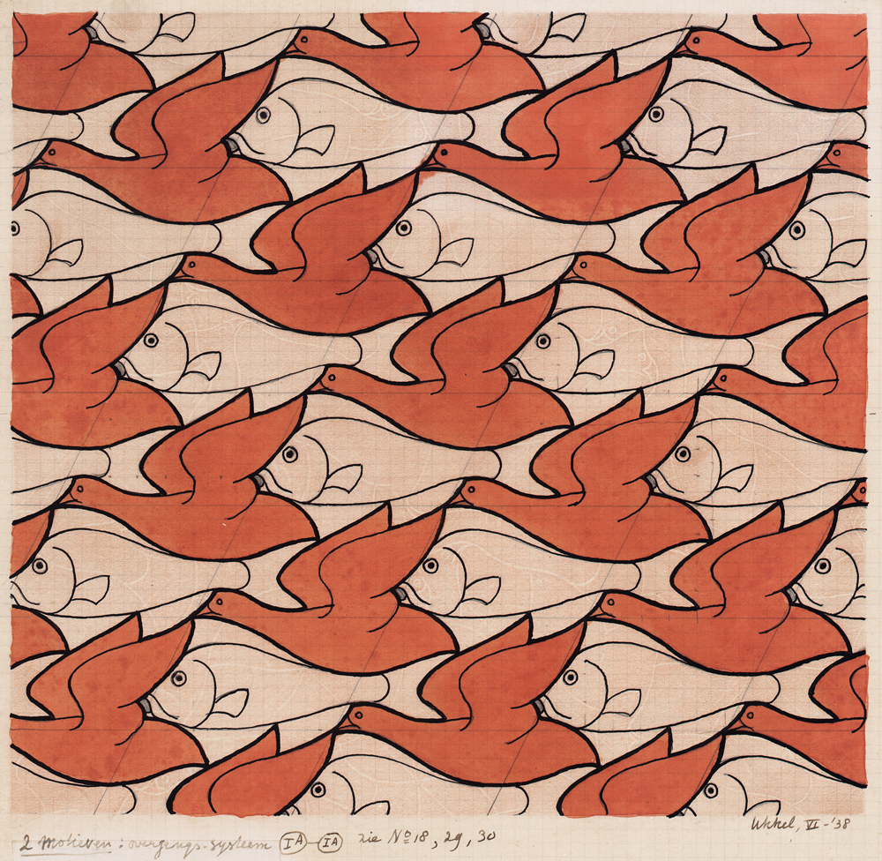

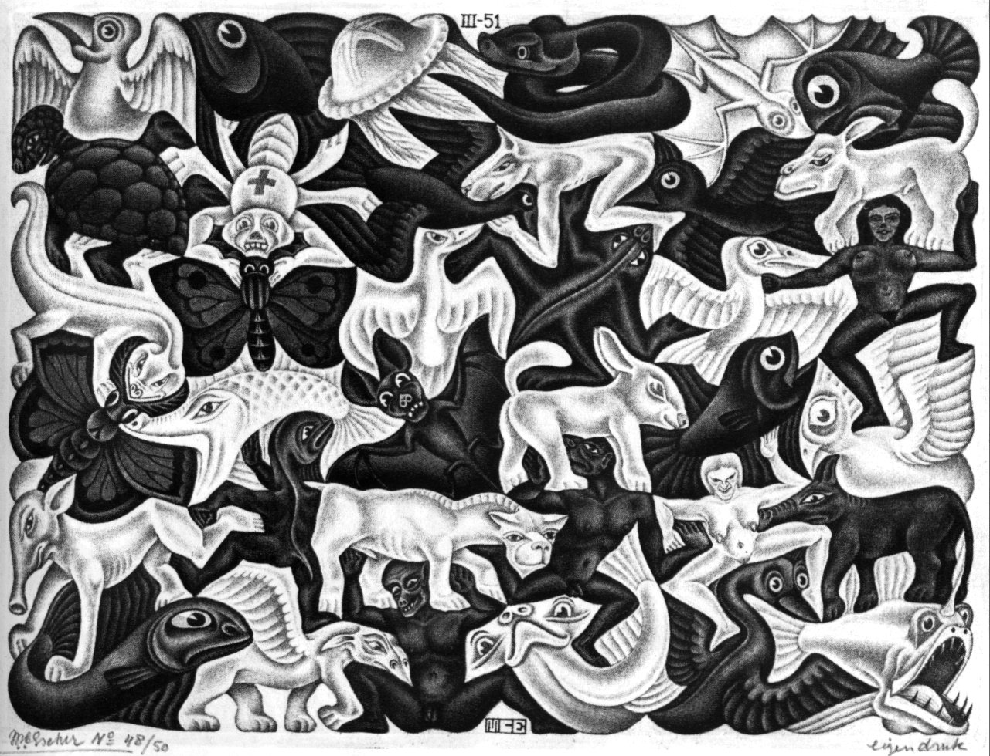

The drawings above are by M.C. Escher and are examples of tessellations. From studying the designs, what do you think a tessellation is?
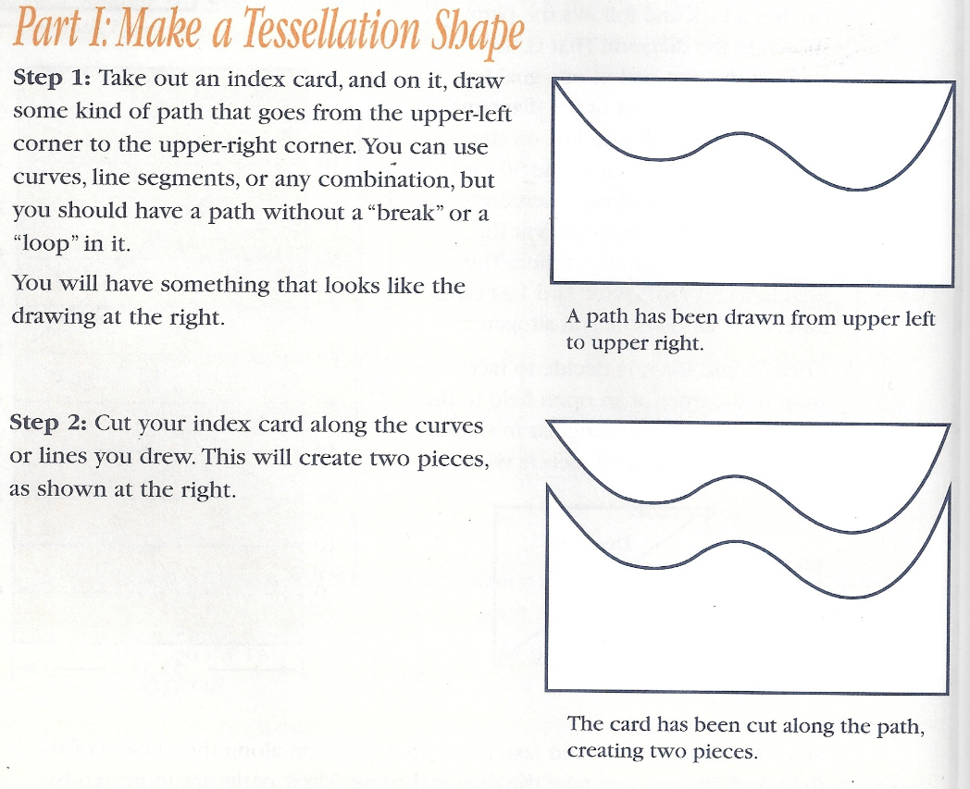
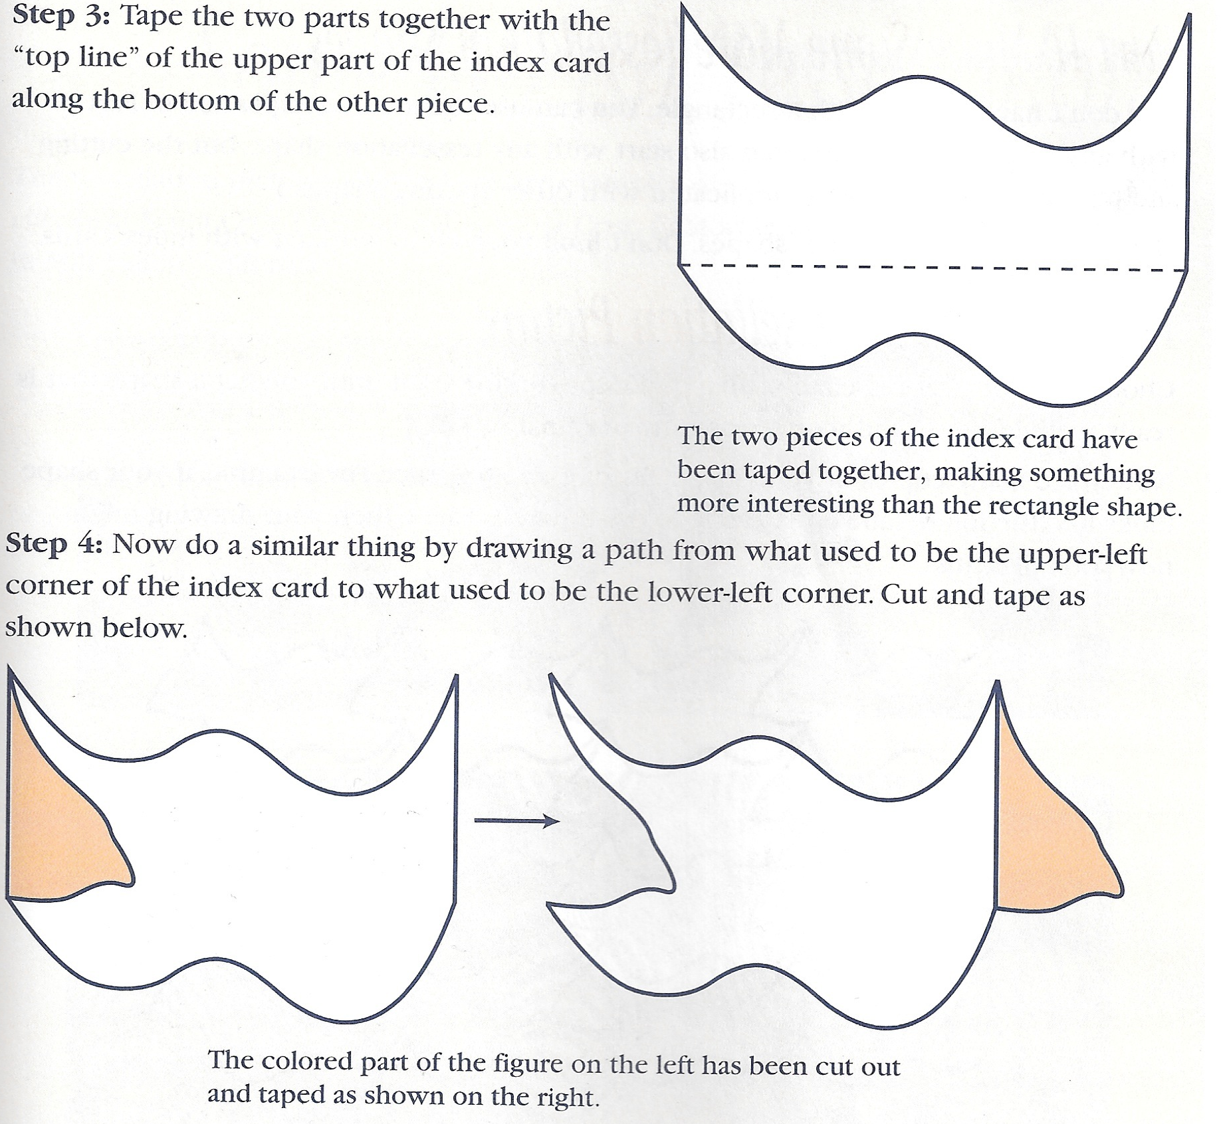
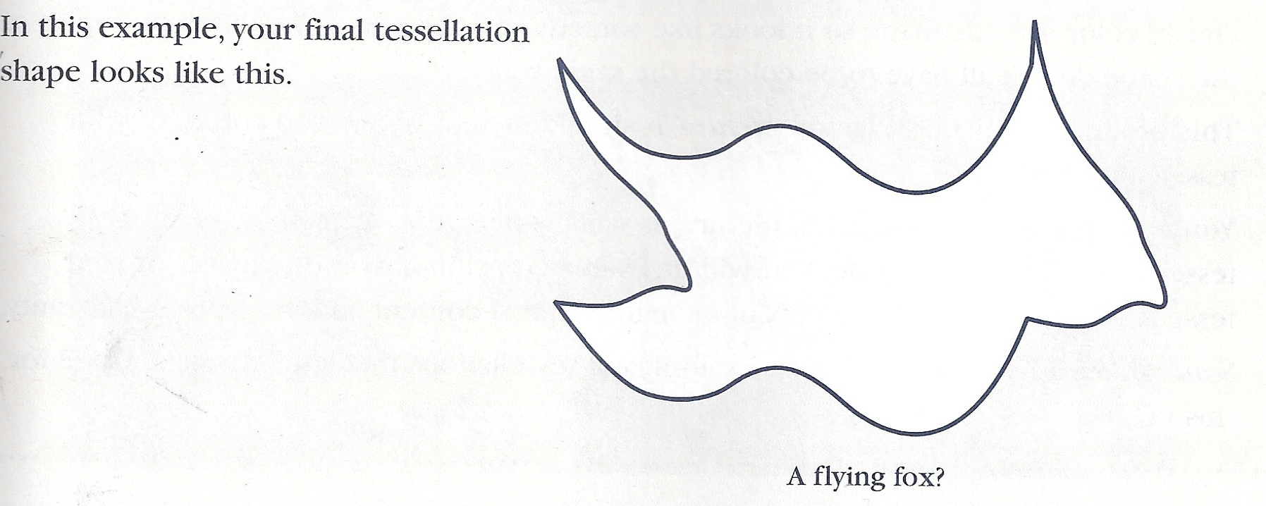
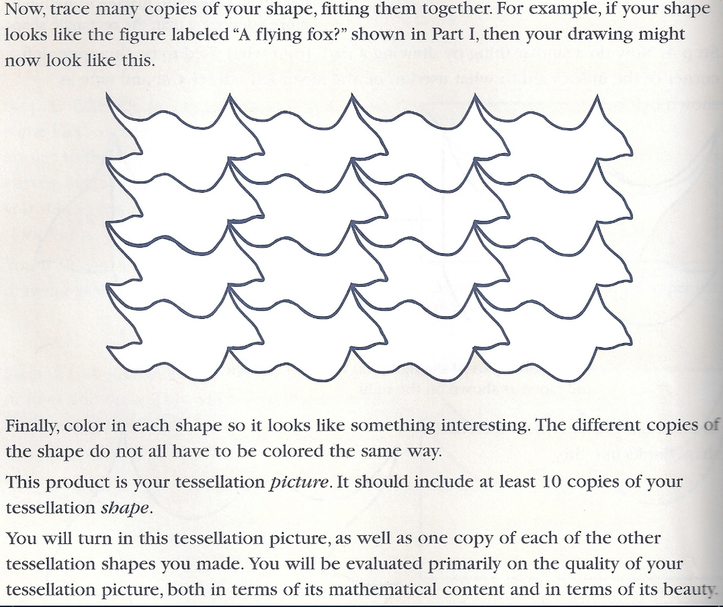

Which Polygons Tessellate?

Get a “shape kit” from the resource table. Use these shapes to complete the chart below:

Number of sides Does it Tessellate? (yes/no)
3 - Triangle

4 - Square

5 - Pentagon

6 - Hexagon

7 - Heptagon

8 - Octagon

9 - Nonagon

10 - Decagon

∞ - Circle

Q5: Which shapes tessellate?

Q6: Why is tessellation important to bees?

Q7: Can we finally answer the essential question: “why do bees build in hexagonal honeycombs?” Discuss in your team and take notes of your conversation below:

Final Analysis Report

You will type up a final report, single spaced, times new roman, 12 pt, not to exceed two pages, addressing the following questions. THIS IS NOT A Q&A, WRITE IN PARAGRAPHS.

Staple your typed report to the back of this packet.

1. What is the Bees Exhibition all about? What did you investigate?

2. What did you discover by finding the volume of many different polygons?

3. Why did you study tessellations?

4. If someone asked you why bees build with hexagonal honeycombs, what would you say to them?

5. Do bees build best, or is there a better shape to build honeycombs with? Why or why not?

