Apartment Redesign Project name:___________________________________________________________________

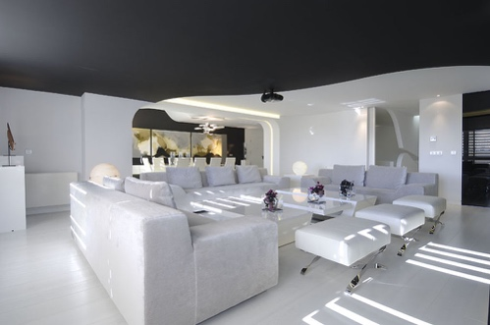
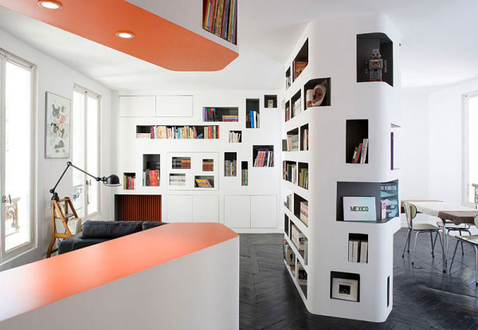
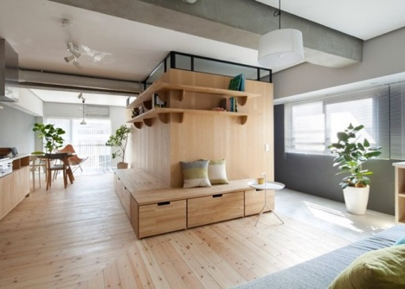

Project assigned: Monday, October| 5 | 2015
Final Review: Monday, October | 12 | 2015

This is the first project you will work in “teams”. Even though you will all be redesigning a different apartment, you should all work together and help each other as you would in an architecture firm.

The first activity will be to cohesify your design team. Each person should spend a few quiet moments thinking of a name of your company. It can be a clever name like “archi-techtonic” or can be a traditional name like “Meyers, Shears, and Simon”. After everyone has brainstormed by themselves, share ideas and come to consensus on what your architecture firm name is:

Our firm name is __________________________________________________________

Now do the same for your logo which you will use for all your branding. Spend a few minutes silently sketching some possible designs in your sketchbook. Label this “Apartment Redesign Logo Brainstorm”. After at least 5 minutes, come together and share possible logo designs. You may want to combine two, or modify one together. After you’ve all come to a consensus about the logo, sketch it here:

You will need to make a “master version” of this logo, whether it be hand-drawn, then scanned, or manually copied. Everyone needs the same version of this logo for their plans, letters, etc. Who will do this master version? ________________________.

Share your emails so that this person can contact others with the digital version or communicate with the others once they are done. Keep in mind, EVERYONE will pull their weight in some way, so don’t assume this logo designer is doing more.

Now you are ready to get your first client(s). Have one of your team members get a Client Packet Kit from the back tables. Distribute Clients to each member and individually perform the Needs Analysis part of the project below.

Needs Analysis

Who is your client? _________________________Their income?____________________

Explain their needs, in your own words, or in a bulleted list:

What is your client’s budget (half their income)?_________________________

Let us say that it costs $100 per square foot to redesign an apartment.

How many square feet can your client afford to redesign?_________________________

Now assess their apartment. How big is each room (include closets for each room)? How big is their whole apartment? Here is a chart to guide you:

Room Actual Dimensions Square Footage

Total square footage (area) of apartment:_________________________

Can the client afford to renovate the whole apartment? If not, which rooms can they afford to renovate? Which take precedent according to their needs? Explain below:

